Daily Goal
There are some goals that you should try to achieve everyday of your class in RP. Create an app that you can check off the goals you have achieved at the end of the day and write the reflection if there are areas for improvement.

The app should look like the image below with
- 3 goals,
- Radio buttons to indicate if goals are achieved,
- EditText to allow user to enter reflection at the bottom and
- The Activity should contain a ScrollView for scrolling.
- Submit button to show a summary of the achievement of goals and reflection in new activity.
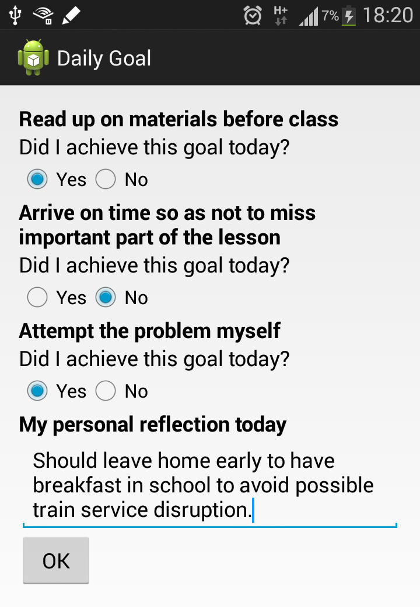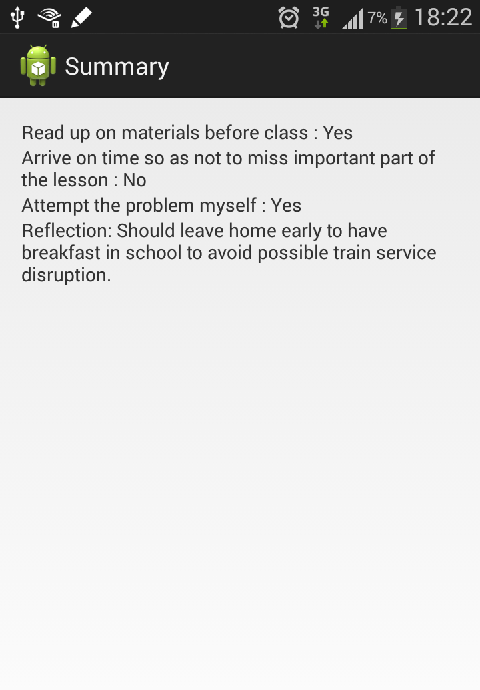

Intermediate Enhancement
Add a button at the Summary activity that closes the Summary activity when clicked.

Advanced Enhancement
When user clicks on the OK button, the radio button choices and reflection should be saved to SharedPreferences. The user can expect the choices and reflection to be populated the same when he/she starts the app again.

